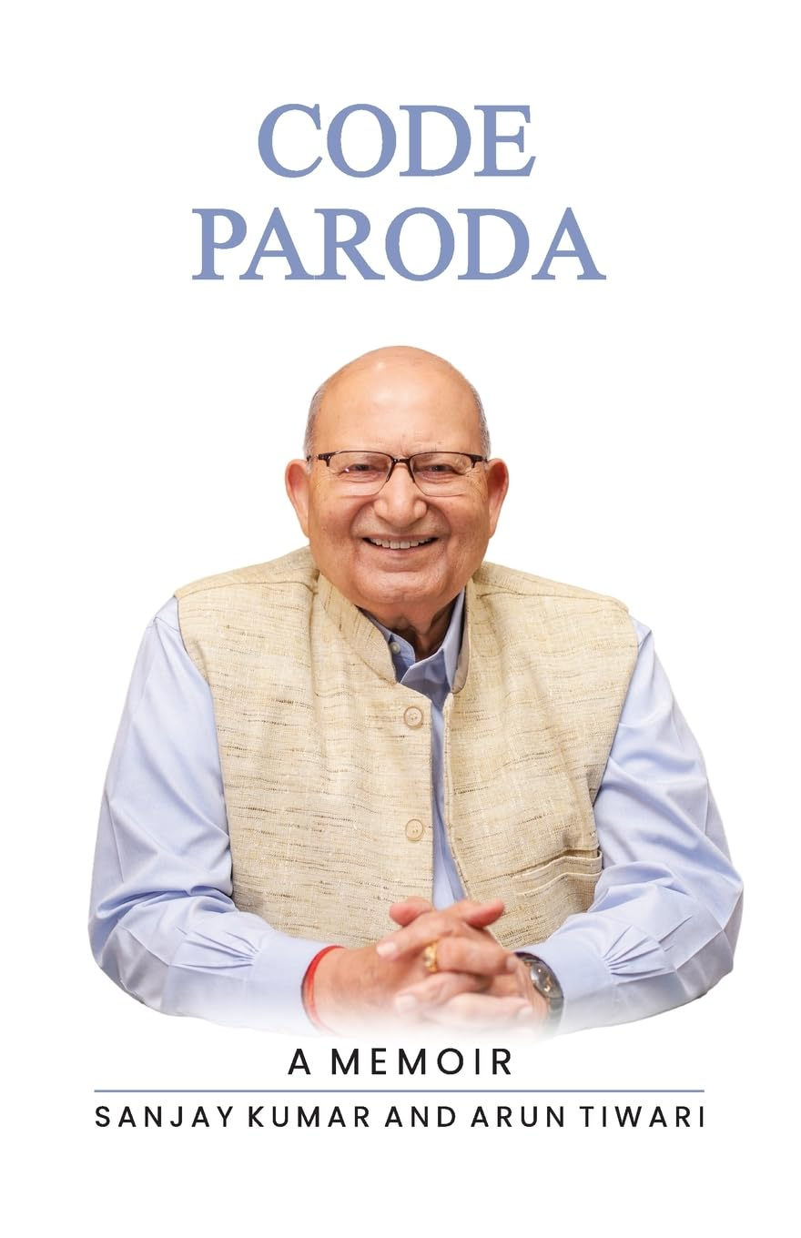
Impressions by Selective Eminent Readers for the Book
CODE PARODA – A Memoir
by Dr Sanjay Kumar and Mr Arun Tiwari

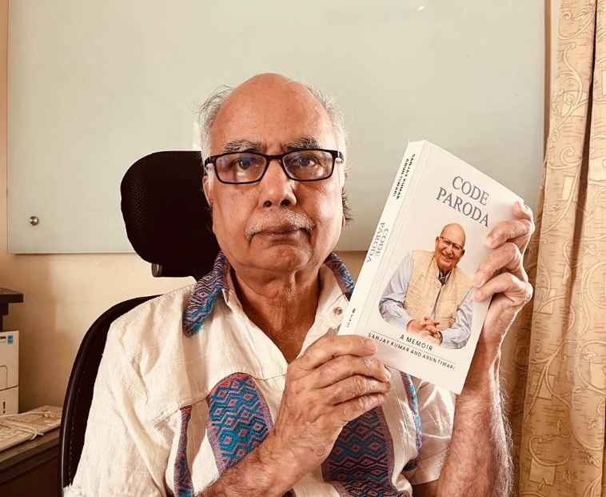
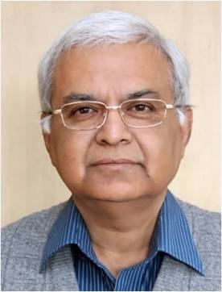

Mr Arun Tiwari - one of the authors who also
wrote Best Seller “Wings on Fire” - on Dr APJ Abdul Kalam.

Dr Sanjay Kumar, Chairperson, ASRB,
New Delhi, One of the Authors

Code Paroda: A Memoir – The Life and Legacy of Dr. R. S. Paroda, Architect of India’s Agricultural Transformation (English Hardcover)
This inspiring memoir chronicles the extraordinary journey, vision, and contributions of Dr. R. S. Paroda, one of the key architects behind India’s agricultural progress and transformation.
A must-read for academicians, agricultural professionals, policymakers, students, and anyone interested in India’s scientific and agricultural history.
Discover the story of leadership, innovation, and dedication that helped shape the future of Indian agriculture. 🌾🇮🇳
Now available on Amazon — grab your copy today and explore the remarkable legacy of Dr. R. S. Paroda.
Shared by Dr Vaibhav Singh
Thanks sir. I have ordered the book and waiting for its delivery by 19 th May from Sakal Publications through Amazon. Writing to all known people to get the book and be privileged to read about the life and legacy of our beloved guide & mentor, a great institutional builder and policy maker. You have always been a source of inspiration to the scientific community for espousing the cause of the farming community. We always feel blessed with your presence. We pray for your long and healthy life.
With warm regards.
Dr Chahal, former ADG (Extn)
Heartiest congratulations Dadaji on the release of CODE PARODA. It makes me truly happy to see your inspiring journey, vision, and immense contribution to Indian agriculture being shared with the world through this book. As my guide and mentor, I have always admired your wisdom, dedication, and the way you continue to inspire generations. I feel proud that through this book, many more people will get to learn from your life, values, and achievements. Wishing you good health, happiness, and continued success always.
Sakshi Tripathi

Good news.I am very happy and order today itself to get your book from Amazon.I will come to your office to take your blessings and your signature on the book for my record and happiness throughout my life.
With kind regards,🙏🙏
Dr PS Sirohi
Heartiest congratulations respected sir for this amazing honour on Amazon. Highest accolades to you sir🙏👏 Your remarkable achievements in Agriculture and specifically modern agriculture is inspiring us and will inspire future generations
With best regards 🙏
Rashmi Aggarwal, Former Dean, IARI
Respected Sir
You are LEGEND and icon for all scientists across different disciplines
So Mr Arun Tiwari placed you to same position as L Abdul Kalam
Heartiest congratulations Sir🙏🙏
Your life, journey, and contributions reflect your dedication to the profession. Your story is inspiration for all of us.
This book is going to be Best seller I will purchase it soon before it goes out of stock🙏🙏. May your story continue to motivate generations to come. 💐
Dr Manish Kumar
Director, central Institute of Goat Research, Mathura

I have read the immensely readable book sir. It has aptly highlighted your extraordinary contributions to Indian agriculture, highlighting your pivotal role in strengthening agricultural research, education, biodiversity conservation, and policy reforms in the post-Green Revolution era. Your leadership transformed institutions, promoted genetic resource conservation, encouraged international scientific collaboration, and contributed to the formulation of India’s National Agriculture Policy. A noteworthy read indeed and highly motivating for me.
Dr Sundram
Director, Rice Institute, Hyderabad
Good evening, Sir.
Great news! Congratulations, Sir, on the book. Our youngsters should have someone they can look up to for inspiration, guidance, and the motivation to move forward and achieve their dreams. This book, through your life journey, should serve as a source of that' inspiration for many young minds.
Warm regards
Sanjay
Sir, you are a great living example whom the younger generation should look at and emulate for coming years. Not easy for anyone to think of contributions u made in one life time! 🙏🏽❤️
Ravi Khetarpal
Respected Sir, I found "Code Paroda" to be a highly engaging and inspiring book, offering significant motivation for both current and future generations of agricultural professionals.Thanks so much Sir.
Dr BS Khadda, Incharge ok KVK at Mohali

Sir, I have forwarded it in some groups with following comments - Fortunately, I have read most parts of "'Code Paroda"' a few months back and I found it absolutely educative and gripping. Far from just a biographical account, it is an inspiring collection of stories detailing Dr. Paroda’s life, his monumental contributions, and his masterful approaches for the empowerment of India's agriculture sector". I am sure that the stakeholders of agriculture including scientists , students , extension functionaries etc. would enjoy reading it.
Dr Ram Srivastava
Dr Sanjay Kumar and Arun Tiwari outlined the life time achievements of Dr Paroda. Their acumen to be appreciated for the comprehensively narrating unequivocal personality of living legend of Indian agriculture of Dr Paroda. These high quality publications would be worth reading and to emulate for the young scientist. With regards
Dr Sandhu, former DDG(CS), ICAR
Thanks Sir for sharing. I always wish and for that pray God also, that you should get the Noble Prize of India. Your contribution to Indian agriculture and thereby nation’s development is immense and great. Profound regards Sir.
Dr RK Mittal, former VC, Meerut
Most Respected Sir,
I am sincerely thankful to the Almighty for giving me the opportunity to learn under the guidance of a globally renowned visionary person like you. Your outstanding and unparalleled contributions to Indian agriculture continue to inspire researchers and the farming community across the nation.
Sir, I pray to God for your good health, long life, and continued blessings so that the country in general, and young researchers like me in particular, may continue to benefit from your invaluable guidance and wisdom.
With highest regards and respect
CM Parihar
Most Respected Beloved Dr. Paroda Sir,
Receiving “Code PARODA – A Memoir” and seeing your documentary is a matter of great honour for me.
The memoir beautifully reflects the life journey, vision, values and monumental contributions of a legendary institution builder and guiding force of Indian agriculture.
The words “A Visionary Par Excellence” truly seem most appropriate for you, Sir.
My sincere compliments to Dr. Sanjay Kumar and Shri Arun Tiwari ji for presenting such an inspiring and meaningful work.
With profound respect, gratitude and admiration. 🙏
Dr Mahendra, IARI
I can Vouch for each part of this Piece. Were together in Ministry of Agriculture dealing with the Subject of Agriculture n Agriculture Research.
Great contribution. Heartiest Congratulations for Singular Achievement.
God Bless you Always n Everywhere.
Taimni, B.K., Former Secretary Agriculture, DOAC, GOI
Good morning my dear Sir. Your contributions are really great Sir. I am always very proud of you. Loving regards and best wishes. Dr. A. Laxminarayana
Respected sir. The video is highly inspiring for all of us. It has a remarkable and impeccable journey from a remote village to the Global platforms with several unique contributions and recognitions. Not every generation of ARS can have a persona like Dr Paroda sir. We feel proud of our profession which has been illuminated by a towering intellectual like you sir. Our deepest regards.
Rabindra and Jasdeep Chatrath Padaria

Respected sir
I salute the writers for their great initiative for an excellent book on the most towering globally known agricultural personality will be encouraging to all the stalk holders I prey almighty for your healthy and long life for the guidance आप को शत शत कोटि नमन
best regards
Sain Dass
This is an extra-ordinary memoir. I want to read through every single sentence of the book and digest its content. Unfortunately, I am suffering from neck pain and undergoing physiotherapy. It will take several days for me to go through the whole book.
In the meantime, I would suggest that the following MOTTO should be displayed in the library of every agricultural College, agricultural University and ICAR institute :
" A good agricultural scientist must possess a combination of scientific knowledge, critical thinking, practical skills and strong communication abilities, all driven by a genuine interest in agriculture and the environment." Dr. R.S. Paroda, you have made above statement on page 56.
Former Prof. PD Tyagi, HAU, Hisar.
Honourable Sir, very inspiring book for all of us. Most importantly the book describes the value system, one should stand for taking it to excellence. It was a great engaging read and valuable collection. Many congratulations to you for sharing your precious memories. With respects, Mohan, NBAGR
Dear sir,
A very well written & compiled story of your journey, interventions, contributions & institution building ; congratulations sir, it will be read by scholars, students & policy makers no less
Prof. Anil Gupta, IIM, Ahmedabad
‘Code Paroda’, is the story of Dr. Rajendra Singh Paroda, one of India’s most distinguished agriculture scientists, who made a signal contribution to the achievement of food security in the country. The memoir, which dwells on the life and times of a visionary scientist, contains many interesting, and hitherto little known, facts about a person who strove to further the legacy of the legendary Dr. M.S. Swaminathan’, the ‘Green Revolution’ ushered in by whom served as a global model for many developing countries. The challenges faced by Dr. Paroda, while addressing concerns relating to food security, and genetic resource conservation, are explained in a gripping first-person narrative, which also goes on to highlight how Dr. Paroda designed the collaborative systems that sustain global agriculture today.
The book provides an insightful look at the behind-the-scenes realities and how Dr. Paroda spearheaded massive advancements in plant genetic resource conservation, and the leadership role he, as the Director General of the Indian Council of Agricultural Research, played, in modernizing India's agricultural research infrastructure and the development of the National Gene Bank. Also described are his achievements as such as the Chair of the Global Forum on Agricultural Research and the Executive Secretary of the Asia Pacific Association of Agricultural Research Institute, advancing crop science and international cooperation in agriculture, across Asia and Central Asia.
It was in 1995, as a Joint Secretary, in the Department of Agriculture and Cooperation of the Ministry of Agriculture of the government of India. That I first had the honour and privilege of meeting Dr. Paroda. For many years thereafter, I enjoyed the good fortunate of associating with him. It was an experience that strengthened my understanding of how those from the other side of Krishi Bhavan could also make their contribution to the national effort aimed at promoting the rapid growth and sustainable development of the agriculture and allied sectors and the cause of food security.
Dr. Paroda’s journey, from a young scientist to becoming the Secretary of the Department of Agricultural Research and Education in the MoA, GoI, will, I feel confident, serve as an inspiring example to agricultural scientists, policy makers, political leaders, the corporate sector and academicians.
The book is an outstanding piece of narration. not only as a personal memoir but also as a record of how scientific leadership, policy vision, and institution-building, helped shape modern Indian agriculture. Endorsed enthusiastically by the world’s leading agricultural scientists, it will bridge the gap between 20th-century innovation and 21st-century ecological stewardship, providing a visionary roadmap for the ‘Viksit Bharat 2047’.
Dr Mohan Kanda, Former Agriculture Secretaty, GOI, and Chief Secretary, Andhra Pradesh
Code Paroda: A Life in Service of Agricultural Science
Book Reviewed: Code Paroda by Sanjay Kumar and Arun Tiwari. 422 pp.
Scientific autobiographies often transcend the lives of individuals to become chronicles of institutions, ideas, and national transformation. Code Paroda, authored by Sanjay Kumar and Arun Tiwari, is one such work. Presented as the life story of Dr. Rajendra Singh Paroda—scientist, institution builder, and former Director General of the Indian Council of Agricultural Research (ICAR)—the book offers a panoramic view of the evolution of Indian agricultural science over the past six decades. More than a memoir, it is a narrative of how vision, leadership, and scientific commitment contributed to shaping India's agricultural research and development landscape.
Structured into four parts—Making of the Man, At the Helm, Ascend, and Legacy—the book traces Dr. Paroda's journey from a farming family in Rajasthan to the highest echelons of agricultural science administration. In doing so, it captures several defining moments in India's agricultural history, including the Green Revolution, the emergence of biotechnology, the conservation of genetic resources, and the growing importance of international scientific collaboration.
The early chapters describe Dr. Paroda's formative years, education, and scientific training. These sections are particularly valuable because they provide a glimpse into the intellectual environment that nurtured a generation of agricultural scientists who would later transform Indian agriculture. His experiences at the Rajasthan College of Agriculture and later at the Indian Agricultural Research Institute (IARI) reveal the critical role played by mentors, institutional culture, and scientific curiosity in shaping successful research careers. The narrative also illustrates how perseverance and openness to opportunity can influence professional trajectories in unexpected ways.
A notable feature of the book is its emphasis on systems thinking. While working at Haryana Agricultural University, Dr. Paroda recognised that the widespread adoption of high-yielding cereal varieties had unintended consequences for livestock production through reduced fodder availability. His efforts to develop forage crop varieties demonstrate an understanding of agriculture as an interconnected system rather than a collection of isolated technologies. This holistic perspective remains relevant in contemporary debates on sustainable agriculture.
The most significant contribution of the book lies in its detailed account of institution-building. Dr. Paroda's tenure as Director General of ICAR coincided with a period of major economic and policy transition in India. The memoir documents the formulation of ICAR Vision 2020, the establishment of specialised national bureaus for genetic resources, the strengthening of agricultural research infrastructure, and the launch of the National Agricultural Technology Project. These initiatives reflected a strategic effort to prepare Indian agriculture for emerging challenges while maintaining its commitment to food security.
Particularly impressive is the account of India's efforts in plant genetic resources conservation. The development of modern gene-bank infrastructure and the strengthening of the National Bureau of Plant Genetic Resources represented landmark achievements in safeguarding agricultural biodiversity. The book highlights how scientific foresight and institutional support can create long-term national assets whose importance often becomes apparent only decades later.
The memoir also provides valuable insights into the evolution of agricultural policy. Discussions on seed sector reforms, biotechnology, intellectual property rights, and public-private partnerships reveal the complex interactions between science, regulation, and development. Dr. Paroda argues consistently for evidence-based policymaking and for regulatory systems that encourage innovation while protecting public interests. Whether discussing hybrid crop development, biotechnology, or genetic resource management, the underlying message is that scientific progress must be accompanied by responsible governance and farmer centric. One of the strengths of Code Paroda is its extensive documentation of national and international scientific networks. The narrative records the establishment and growth of organisations such as the Asia-Pacific Association of Agricultural Research Institutions (APAARI), the Asia-Pacific Consortium on Agricultural Biotechnology (APCoAB), and the Trust for Advancement of Agricultural Sciences (TAAS). Through these initiatives, the book demonstrates how agricultural innovation increasingly depends on collaboration across disciplines, institutions, and countries. (contd.)

The chapters describing Dr. Paroda's post-retirement contributions are equally engaging. Rather than withdrawing from public life, he continued to play a major role in fostering scientific dialogue, strengthening regional cooperation, and promoting policy engagement through TAAS and international organisations. The discussions on climate change, agrobiodiversity, soil health, and youth engagement illustrate his continuing commitment to addressing emerging challenges in agriculture.

An important contribution of the book is its reflection on leadership. Throughout the narrative, successful leadership is portrayed not merely as administrative authority but as the ability to build institutions, nurture talent, create partnerships, and inspire collective action. The memoir repeatedly highlights the contributions of colleagues, mentors, and collaborators, underscoring the inherently collaborative nature of scientific achievement.

The book is enriched by numerous anecdotes involving leading scientists, policymakers, and development practitioners from India and abroad. These accounts provide readers with a rare insider's perspective on the functioning of agricultural research systems and the personalities who shaped them. Future historians of agricultural science will find considerable value in these first-hand observations.

The concluding section, which outlines the "Code Paroda," serves as both reflection and roadmap. Covering themes such as climate resilience, public science, nutrition security, digital agriculture, water management, youth engagement, and collective action, the framework reflects a lifetime of experience in science and policy. While ambitious in scope, it is grounded in practical lessons drawn from decades of engagement with farmers, researchers, and institutions.

Overall, Code Paroda is an important contribution to the literature on agricultural science, science policy, and institution-building in India. It combines personal narrative with historical documentation and policy reflection, making it relevant to a broad readership that includes scientists, students, policymakers, administrators, and development practitioners. The book reminds us that agricultural transformation is not driven solely by technological breakthroughs; it also requires visionary leadership, strong institutions, and sustained public commitment to science.

At a time when agriculture faces unprecedented challenges arising from climate change, resource degradation, nutritional insecurity, and technological disruption, the experiences and reflections presented in this volume acquire particular significance. Code Paroda is therefore not merely the story of an accomplished scientist; it is also a thoughtful account of the evolution of Indian agricultural science and a valuable source of lessons for its future
The memoir also provides valuable insights into the evolution of agricultural policy. Discussions on seed sector reforms, biotechnology, intellectual property rights, and public-private partnerships reveal the complex interactions between science, regulation, and development. Dr. Paroda argues consistently for evidence-based policymaking and for regulatory systems that encourage innovation while protecting public interests. Whether discussing hybrid crop development, biotechnology, or genetic resource management, the underlying message is that scientific progress must be accompanied by responsible governance and farmer centric.
One of the strengths of Code Paroda is its extensive documentation of national and international scientific networks. The narrative records the establishment and growth of organisations such as the Asia-Pacific Association of Agricultural Research Institutions (APAARI), the Asia-Pacific Consortium on Agricultural Biotechnology (APCoAB), and the Trust for Advancement of Agricultural Sciences (TAAS). Through these initiatives, the book demonstrates how agricultural innovation increasingly depends on collaboration across disciplines, institutions, and countries.
The chapters describing Dr. Paroda's post-retirement contributions are equally engaging. Rather than withdrawing from public life, he continued to play a major role in fostering scientific dialogue, strengthening regional cooperation, and promoting policy engagement through TAAS and international organisations. The discussions on climate change, agrobiodiversity, soil health, and youth engagement illustrate his continuing commitment to addressing emerging challenges in agriculture.
An important contribution of the book is its reflection on leadership. Throughout the narrative, successful leadership is portrayed not merely as administrative authority but as the ability to build institutions, nurture talent, create partnerships, and inspire collective action. The memoir repeatedly highlights the contributions of colleagues, mentors, and collaborators, underscoring the inherently collaborative nature of scientific achievement.
The book is enriched by numerous anecdotes involving leading scientists, policymakers, and development practitioners from India and abroad. These accounts provide readers with a rare insider's perspective on the functioning of agricultural research systems and the personalities who shaped them. Future historians of agricultural science will find considerable value in these first-hand observations.
The concluding section, which outlines the "Code Paroda," serves as both reflection and roadmap. Covering themes such as climate resilience, public science, nutrition security, digital agriculture, water management, youth engagement, and collective action, the framework reflects a lifetime of experience in science and policy. While ambitious in scope, it is grounded in practical lessons drawn from decades of engagement with farmers, researchers, and institutions.
Overall, Code Paroda is an important contribution to the literature on agricultural science, science policy, and institution-building in India. It combines personal narrative with historical documentation and policy reflection, making it relevant to a broad readership that includes scientists, students, policymakers, administrators, and development practitioners. The book reminds us that agricultural transformation is not driven solely by technological breakthroughs; it also requires visionary leadership, strong institutions, and sustained public commitment to science. At a time when agriculture faces unprecedented challenges arising from climate change, resource degradation, nutritional insecurity, and technological disruption, the experiences and reflections presented in this volume acquire particular significance. Code Paroda is therefore not merely the story of an accomplished scientist; it is also a thoughtful account of the evolution of Indian agricultural science and a valuable source of lessons for its future.
Dr A Amarender Reddy, Joint Director, ICAR-NIBSM, Raipur

Respected Dr Paroda
I have gone through the book CODE PARODA, a memoir authored by Dr Sanjay Kumar Chairman ASRB and Dr Arun Tiwari so kindly sent by Dr Anuradha Agarwal, General Secretary ISPGR, New Delhi. The memoir has documented your journey from the village Saradhana and also the stewardship for agricultural development to the present day. The memoir serves as an enduring testament to what a driven mind and a compassionate perspective can achieve. It is a journey of an outstanding innovator, an able institutional builder and a humanist with deep sympathy for the farmers. You established the first Gene Bank in NBPGR and also providing able leadership for the second one and hope it would be a reality soon. The book is very inspiring and motivational to the students, scientists, farmers, policy makers and all those associated with agricultural development directly or indirectly. We all wish you a long and healthy life.
There could not have been better authors than Dr Sanjay Kumar and Dr Arun Tiwari to pen down this memoir. Dr Sanjay Kumar devoted his career to CSIR-IHBT and has worked extensively in bioprospecting high altitude Himalayan medicinal and other useful plant resources. Prof Arun Kumar is an equally accomplished missile scientist. I must thank Dr Anuradha Agarwal a dedicated scientist and General Secretary ISPGR for sending me a copy of the memoir. I had the privilege of working with her and learning a lot during my stay in NBPGR. With profound regards.
Prof SK Sharma, Honorary Professor & Former Vice-Chancellor
HP Agricultural University, Palampur
Dear Raj,
Hearty congratulations. I have been reading the book “Code Paroda”. It is a high-class narrative of a great agricultural scientist of India. It will be a source of inspiration for generations to come.
In substance, quality of writing ,and composition , I would grade "Code Paroda” with A plus. In comparison, I would not have enough courage to grade my own book.
I was not successful in getting a publisher for some time. Coincidentally, I published a book with CABI as a co-editor of Dr Adel El Beltagi . Thus, I asked my contact at CABI if he would publish it , and he eventually agreed . But, its price ,as he told me , will be high, and it is.
Since then, my contact at CABI has taken job with another publisher . His successor has recently been appointed ,to whom I have been in contact with for ordering a few hard copies. I hope to get a few copies by July/August. I will be pleased to send you a hard copy.
I feel proud and thankful for having a copy of “ Code Paroda”. I will treasure it for ever.
Best regards
Rattan Lal
Most Respected Dr. R. S. Paroda Sir
After reading Code Paroda, I felt I was not just reading a book, but learning from a life full of dedication, honesty, struggle, values and service to Indian agriculture and farmers.
Being from the same village and studying in the same school made this book very emotional and special for me. When I read the names of teachers and places connected with your journey, I felt deeply connected. My father was also taught by the same respected teachers mentioned in the book. It gave me great pride that the same soil, same school and same values are connected to both our journeys.
This book touched my heart because every chapter carries real experiences, deep wisdom, and lessons for life.
Some parts of the book stayed with me deeply:
• Reading about great personalities through your experiences made the book even more inspiring for me .
• The journey of building NBPGR and the National Genebank inspired me greatly. It taught me that strong institutions are created through patience, sacrifice, hard work and vision.
• The “Trial by Fire” chapter was very emotional for me. The way you faced difficult times, false allegations, and pain with dignity and inner strength reflects your true character.
• Your thoughts from the Bhagavad Gita and the idea of “Code Paroda” are powerful life lessons for young generations. They teach honesty, duty, courage, humility and service to society.
• The chapter “For Whom the Bell Tolls” touched me deeply. It reminded me that real success is not position or power, but the positive impact we leave on people, institutions and society.
Sir, what impressed me most is that even after reaching such great heights, you remained connected to farmers, villages, teachers, family values and the soil of India. That simplicity and grounded nature make your journey truly inspiring.
For me, reading this book felt like learning from an elder of my own family and village. It filled me with pride, emotion, motivation and responsibility.
Sir, legends like you are born very rarely. Your life is not only an inspiration for agriculture, but also for humanity, honesty, dedication and service to society. I truly feel that words are too small to express my respect and feelings for you. I do not even dare to fully describe your greatness in words. I can only offer my heartfelt salute and gratitude to you for everything you have given to our nation, farmers, science and future generations
Thank you, Sir, for giving such a valuable gift to future generations through this book. Your journey will continue to inspire many people for years to come.
With deepest respect and regards
Dr. Anand Choudhary

Respected Raj Paroda Sir,

Greetings from DharmaKshetre - Kurukshetre!

Having completed reading Code Paroda , I wish to express my heartfelt gratitude for sharing this remarkable memoir. More than a personal narrative, the book is a masterclass in vision, leadership, institution building and unwavering commitment to the advancement of Indian agriculture.

Every chapter reflects your extraordinary journey as a scientist, administrator, reformer, and global ambassador of agricultural development. I was particularly inspired by how you transformed challenges into opportunities and built institutions that continue to serve the nation and the scientific community. The book provides invaluable insights into the evolution of India's agricultural research system and the people, ideas and values that shaped it.
For me, Code Paroda is not merely a biography; it is a source of inspiration, wisdom, and guidance for present and future generations of scientists. It has reinforced my belief that transformational leadership, when guided by vision, integrity and dedication, can leave a lasting imprint on society.

Thank you for this priceless gift. It will remain a treasured possession and a valuable reference throughout my life.

With deepest respect and warm regards,
Surender
----------------------------------------------------------
Prof (Dr) Surender Singh DHANKHAR, FAAM
PhD-Dual Gold Medalist, PDFs-Austria, Brazil, Italy & Switzerland
NET (1991), ICAR-ARS (1991), IMD (1991), SAC-ISRO (1992)
Fellow-Association of Agrometeorologists (FAAM)
Sr Professor/Principal Scientist - Agrometeorology
Core Member, SC-AGR-ET-DRG, WMO, Geneva, Switzerland
Member, Expert Team - CAgM-WMO, Geneva, Switzerland
Ex Chairman - Association of Agrometeorologists (HC)
Captain Gold Medalist University Handball Team-1988
President, University Handball Club (1993-2018)
Associate Director (C&P), Adviser (Recruitments)
Coordinator-University SPARC Projects - MoE, GoI
Managing Editor - Journal of Agrometeorology
National Vice President - AAM and Head
Department of Agril Meteorology, CoA
CCS HAU Hisar-125 004, Haryana,INDIA
Cell # +91 9416092462 @ A-1(जलवायु)

